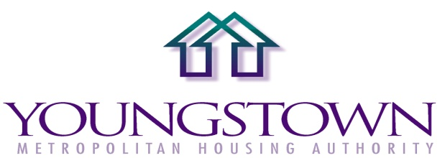
NOTICE
JOB BID IN MAINTENANCE DIVISION
(AFSCME LOCAL 288)
BIDS WILL BE RECEIVED ONE (1) FOREMAN (UNION)

POSITION SUMMARY: Will coordinate and plan the routine and non-routine maintenance requirements of assigned site. Will perform ordinary and difficult repairs to interior and exterior of structures, equipment and mechanical systems. Will perform general cleaning of shops and offices; and general cleaning of apartments being prepared for rental. Will also perform general maintenance and upkeep of grounds. Will be responsible for supervision and training of assigned maintenance staff.

Hourly Rate: $26.13

Hourly Rate $23.17
Employees hired
After September 1, 2007

Date of Posting Friday, April 9, 2026

Date of Closing Monday, April 20, 2026

All bids must be received by 4:30 p.m. Monday April 20, 2026. Please submit all bids to the Director of Human Resources.
131 West Boardman Street Youngstown, OH 44503-1399
330-744-2161 Fax 330-742-4826 TDD: 330-742-2996


